Milford Haven Community Primary School

Ysgol Gynradd Gymunedol Aberdaugleddau

‘Where every child matters and every moment counts’



Positive Behaviour Policy

Member of SLT responsible for this policy | Headteacher
This policy follows on from the Anti-bullying and behaviour policies that were adopted at The Meads Infant and Nursery School and MHJS. All systems and processes have been reviewed with staff, September 2023.
Date adopted by new governing body | 11/12/18 | Chair of governors’ signature
Reviewed | October 2019 | Adrian Armstrong 12/11/19
Planned review date | October 2020 Reviewed Dec 20  Updated 01.11.21  Reviewed October 22 | Adrian Armstrong 10.12.20  Adrian Armstrong 10.12.21
 | Edited March 2023

Contents Page

- Vision

- Values and expectations

- Building positive relationships
- Pupils
- Parents, carers and families
- Parent communication lines with designated staff

4. Preventing behaviour problems
-Teaching – engagement, differentiation, routines and timetables
- CALM communication
- Positive reinforcement script
- 30 second intervention
- re directing behaviours in a positive way script

5. Rewarding positive behaviour and consequences to unacceptable behaviours

6. How to resolve difficulties and repair relationships (RR)

7. Record Keeping- Statutory Prejudice Bullying Reporting/Prejudice related incidents

8.Attendance

9. Offensive Weapons

10.Drugs, alcohol and illicit substances

11.Use of Mobile phones and Smart watches

12. Supporting individual pupils needs

13. Positive Handling – Team Teach

14. Exclusions -fixed term and permanent

15. Advice for all stakeholders on how to report and deal with reported incidents of bullying

1.Our vision

To create an inclusive school, where every child’s mental, emotional and physical wellbeing is nurtured to ensure each and every child is ready to learn and succeed to the best of their ability; whilst also developing a strong understanding of their role within their community and the world around them.

Our Aims
- An inclusive environment which nurtures every pupil's social, emotional and mental wellbeing
- A school that provides daily opportunities for the children to live a healthy and active lifestyle, supporting their wellbeing and physical fitness.
- A school that ensures all children can speak, read and write and use these skills across the curriculum with confidence.
- A school that ensures children's Mathematics and Numeracy skills are strong.
- Opportunities for pupils to develop a wide range of digital skills fit for the 21st century.
- An understanding for every pupils about the importance of being part of their community in a positive way.
- Opportunities to develop creative, musical and practical skills, as well as to have a strong understanding of the world around them.
- A school that provides over and above support to ensure learners needing extra support can be successful and learners needing to be challenged to get the very best out of them receive the support needed.

Pupils, parents, teachers and support staff all take collective responsibility for the promoting of positive behaviour in Milford Haven Community Primary School



2. Our Values and expectations


Honesty
Respect
Positivity

Perseverance
Fairness
Kindness

Consistent, calm adult behaviour

First attention for positive behaviours

Relentless routines

Scripting difficult interventions

How to resolve difficulties and repair relationships

3 .Building Positive Relationships

With pupils

Staff skills in managing behaviour in the class depend upon the quality of their relationship with the children. Over time, teachers and staff must build up trust and empathy with the children as this establishes the basis for all tasks involving future behaviour management and therefore learning.

- Personal and positive greeting
- Speaking calmly and patiently.
- Listening; avoiding judgements or critical responses
- Sincere, enthusiastic, and positive feedback about ideas
- Personalise communications with individuals (E.g. special interests, hobbies, life outside setting)
- Special time with each child (snack time, unstructured playtimes)
- Positive chats with parents
- Recognizing birthdays
- Promote positive self-talk; communicate belief in their success.

With parents, carers and families

Parents are usually the child’s first and most influential teachers. Therefore, building good relationships with parents, carers and the wider extended family is extremely powerful in helping to build a child’s success both in school and at home. The involvement of parents or carers in their children’s learning leads to greater problem-solving skills, greater enjoyment of school, better attendance, fewer behavioural problems and greater social and emotional development.

The school will promote parental/carer involvement by:
- Ensuring effective home-school communication through newsletters, termly curriculum letters, parent’s evenings, School Facebook page, the school website with live school calendar, Parent App, message boards and other means available. The most effective form of communication is face-to-face contact with staff. It may not always be possible to speak to the class teacher at the start of the day as they prepare the first session, but other school staff, e.g., the headteacher or classroom assistant will often be on hand to discuss any concerns. Teachers will generally be more available at the end of the school day to meet with parents and carers, who are invited to call in for an informal chat as and when it may be needed.
- Sharing our learning assemblies. These take place annually and give parents and carers a chance to celebrate pupil learning through the year.
- Watch me learning events. Some classes at different times of the year will invite parents in to watch learning ‘in action’.
- Special events. E.g., sports day, concerts, fetes
- In-school Parent Learning groups e.g., Springboard
- Using questionnaires to gain important feedback.
- Information sharing sessions. This may involve demonstration lessons, presentations and so forth around new teaching initiatives, residential, transition to secondary schools and so forth.
- Involving parents fully in their child’s education in relation to additional learning needs and behaviour, through regular meetings and joint action planning, with school and local authority support staff.
- Creating and supporting appropriate links with school support services

Parent lines of communication with designated staff

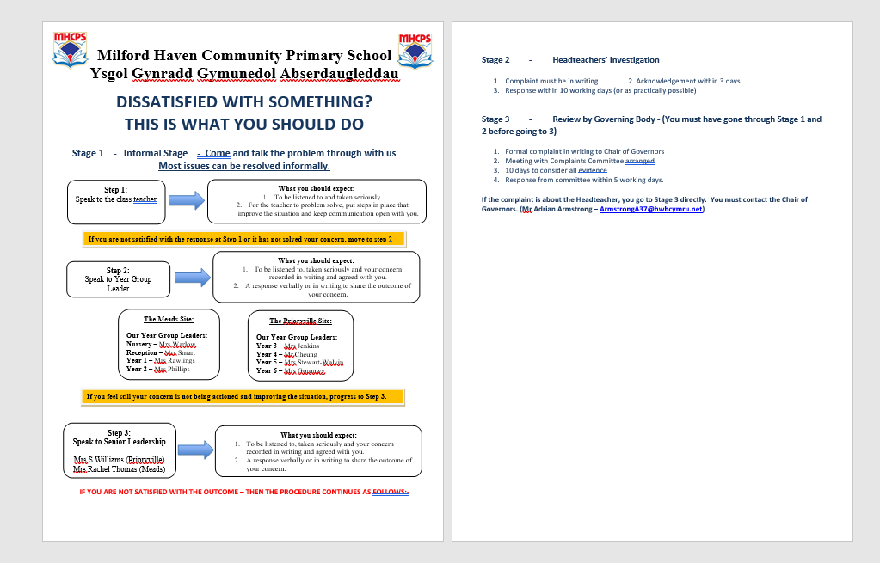

4. Preventing behaviour problems

Good teaching- The management of behaviour will have a significant impact upon the teaching and learning which takes place in the classroom. However, the converse is more important still – The quality of teaching has a significant impact upon the quality of behaviour in the class. Two aspects of classroom teaching which can affect behaviour more significantly are – engaging pupils and differentiating work appropriately.

Engaging pupils - We aim to start each lesson in an active, engaging manner. This means that pupils will not be sitting on the carpet listening for a long time where problems can sometimes begin. Most lessons should start with the teacher talking for no longer than 4 minutes and pupils actively engaged in within this time, and where possible, sooner.

Differentiation -Differentiation, in all its forms, is a central feature of effective management of classroom behaviour. Differentiation is the process whereby teachers attempt to help pupils of different abilities fulfil their achievement potential. We believe that good preparation and differentiation goes a long way towards addressing issues of frustration or boredom in the class, and therefore decreases the chances of disruptive behaviour taking place.

In order to ensure all pupils are engaged in appropriately accessible and challenging work whenever possible, teachers will:

- Plan work for children to be working at the right level in order to make optimum progress.
- Prepare resources for pupils to be working at an appropriate level to progress.
- Only differentiate by outcome where this is the most appropriate method of differentiation for the pupil to make optimum progress.
- Ensure pupils have access to visual or other support aids where necessary to allow them to access the learning with a minimum of support.
- Ensure that more able pupils complete different work to their peers and challenges their learning.
- Ensure that pupils with additional learning needs are regularly given tasks they can complete without support.

Rules, routines and timetables

All teachers will meet their pupils at the end of break time and ensure pupils re-enter the class in a calm manner before engaging in lessons. When pupils are being given a consequence such as paying back some of their break times, it is the class teacher’s responsibility to supervise and provide an activity for pupils during this time.

The core value of respect runs through all of these rules. Each class has a set timetable for the week and these are adhered to with some exceptions.

CALM communication - modelled by all school staff

C communication – stance, posture, gesture, facial expression, intonation, scripts, respectful, even in the face of challenging behaviour, maintaining emotional control, speaking clearly, NEVER shouting unless someone is at risk of immediate harm.
Awareness and Assessment – reading behaviour, anticipating what might happen next, knowledge of handling plans, not talking to other staff about children in front of the child
Listening and learning – give time and space, allow pause for take up time, give them a way out
Making safe – objects, space, hot spots, safety responses.

Positive Reinforcement Script
Positive Reinforcement.
I like this ……………………………………………….. because …………………………………………………………..
I really like it when you ……………………………………… because ………………………………………….
I see you have ……………………………………………………………………………………… That’s amazing!
I am really proud of you for ………………………………………………………………………………………….
When you …………………………………………………….. it makes me feel………………………………………
I am so pleased because I can tell you have really tried hard to ……………………………
Can you see I am happy because you have …………………………………………………………………….
How do you think …………………………………... feels when you ……………………………………………?
Thankyou for helping me ……………………………………………………………………………………………..
Well done for ………………………………………………………………………………………………………………….
Deciding to ………………………………………………………………………………………… was a good choice!
Playfulness not consequences at that point
Liking the child –showing you like the child, even if they reject you (I like you, but I don’t like that behaviour. Reconnect quickly after correcting behavioural mistakes)
Accepting – sometimes traumatised children “can’t rather than won’t” do something
Curious – Being curious, wondering why children do certain things rather than angry can sometimes be more effective in achieving change.
Empathy – validating feelings is important for children , especially those who have experiences trauma

30 second intervention - GET IN AND GET OUT

30 second intervention is to be used in order to allow the pupil to self-regulate and adjust their behaviour accordingly.

Non-threatening, on their level and by their side
I’ve noticed…
I need you to…
You have chosen…
Do you remember…
That is the behaviour I need to see today…
Thank you for…

Re-directing Behaviours in a Positive Way.
It would make me happy if you could try to …………………………………………………………………..
We are not going to talk about this right now as we are ………………………………………..….
You can either choose to ……………………………. or you can choose to …………………………..… Which are you going to choose first?
You need to …………………………………………………………………………………………………….... Thankyou.

5.Rewarding positive behaviour

 Dojo points will accumulate throughout the year.

Dojo rewards - Individual awards to ensure consistency across all classes.

10 - change monster
20-sticker from SLT
50 - Hot Chocolate / Milkshake
70 -sticker from SLT
100 - Surprise gift
110 - change monster
120-sticker from SLT
150 - Hot Chocolate / Milkshake
170 -sticker from SLT
200 - Free item from the tuck shop
210 - change monster
220-sticker from SLT
250 - Hot Chocolate / Milkshake
270 -sticker from SLT
300 - Surprise gift

 Marbles in the jar will be awarded as a class reward. The class will then decide as a class on the reward for positive behaviour and check in with SLT to ensure it is appropriate and able to be facilitated.

Consistent responses are essential – what is acceptable today must be acceptable tomorrow.

Where behaviours are not acceptable there are stepped consequences. These are to be used as a guide and MUST be discussed with all parties involved during the Reflect and Repair process.

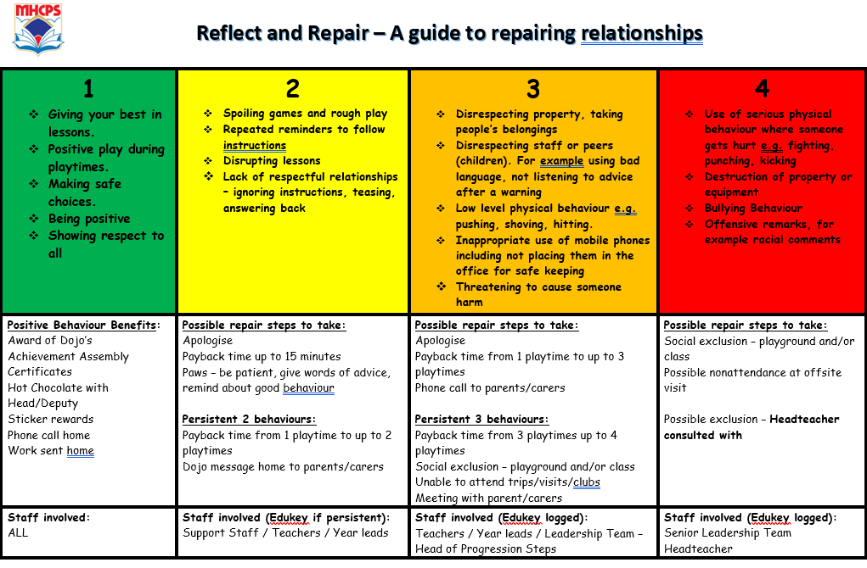

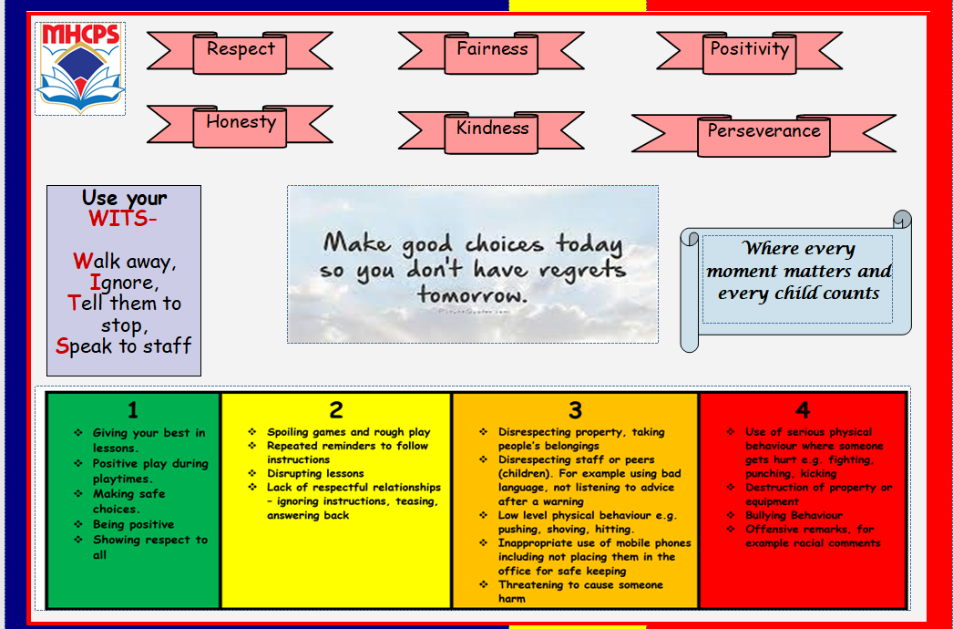

6. How to resolve difficulties and repair relationships

Repairing.
I like you but I don’t like your behaviour when …………………………………………………………….
When you ……………………………………………… I ……………………….…………………… I like it better when ………………………………………………………………………………………….
e.g … When you shout at me I find it hard to listen. I like it better when you talk quietly so we can talk together. I can listen to what you’re saying better when we talk quietly.

REFLECT AND REPAIR CHAT RECORD (RR Record)
Reflect on the situation and repair relationships

Challenging Behaviour Name:  Year Group – |  |  | Harmed Participant :  Year Group -
Date: | Time Start | Time End | Location:
(Please record main points in bullet form)
- Can you tell me what happened? (Emphasize that one person speaks at a time and give all a turn to have their say)

- How did this situation make you feel? (Direct it to specific actions and support children in identifying how they may have been feeling at the time

- What could we do differently next time and how are we going to fix this? (To make sure it doesn’t happen again)

Signed by young people: 1._____________2._____________3.___________4._______

Signed by adult: ______________________________________________

Monitored by: ________________________________________________

6.Statutory Reporting

- Bullying
- Prejudice related incident
- Safeguarding

In line with the Welsh Government ‘Challenging Bullying’ statutory guidance which places a duty on schools to respond to and record all forms of bullying including prejudice related bullying, the LA has revised the way in which they collate this data for reporting to WG and to be more responsive to issues arising in our county.

For this reason and in line with the requirement to record bullying incidents prejudice related bullying including racial incidents are now to be reported by schools by completing the

Equalities - Pembrokeshire Schools Online Reporting Incident Form
Cydraddoldebau – Ffurflen Adrodd Digwyddiad Ar-lein Ysgolion Sir Benfro
7. Attendance
Pupil attendance is extremely important in Milford Haven Community Primary School.
For safeguarding reasons, pupils at Milford Haven Community Primary School are not allowed to leave site in the school day without prior consent from their parent/carer. Should a pupil leave school without consent then the school’s emergency procedures will be followed.
See Child Missing From School policy

8.Offensive Weapons

Offensive weapons are defined in the Prevention of Crime Act 1953 as ‘any article made or adapted for causing injury to the person or intended by the person having it with him/her for such use.’ This includes ‘any article which has a blade or point or is sharply pointed.’ We define this further by making it clear that all pocketknives are included in this definition for the purposes of maintaining school discipline and the safety of the whole community.

Pupils who have an offensive weapon will have it removed from them. It will not be returned to the pupil. The parent/carer will be informed and may request permission to pick the article up from the school. A decision about whether this will be granted will be made in liaison with the police where necessary.

9.Drugs, alcohol and illicit substances

If staff or pupils report a suspicion of any person involved with drugs or alcohol then the person/s will be spoken with, possibly searched and parents contacted. In some circumstances a search may take place without consent, provided it is carried out within the boundaries set by the Department of Education (www.gov.uk/school-discipline-exclusions/searches).

Any item found will be confiscated. Drugs (and any paraphernalia) will be removed from the school site by the police; alcohol will be destroyed.

Any incident relating to illegal substances will be reported to 101 or 999 depending upon the seriousness of the incident. In addition to this, appropriate consequences will be considered by the school. If a pupil is found with tobacco or e-cigarettes, parents will also be informed and appropriate sanctions will be issued.

10.Use of Mobile phones

The use of smart watches / mobile phones by pupils is prohibited during the school day. Pupils are also encouraged to hand them the school offices at the start of the day and collected at the end of the school day. If seen, they will be asked for the phone to be kept in the school office by a member of staff and again only returned at the end of the school day.
11. Supporting individual needs.

- In our School there are identified Additional Leaning Needs children, some of whom have specific medical needs. Further strategies may be required in order to meet the individual needs of these children, and strategies will be detailed in their Individual Development Plans. (IDP’s)
- Children with specific behavioural issues may also have a Positive Holding Plan (PHP’s).
- PHP’s are reviewed as and when needed. Copies of these are also shared with parents and signed as necessary. These PHP’s link directly with Team Teach strategies.
- At Milford Haven Community Primary School we have a full time Nurture support facility on both sites. The focus of this group is to further develop social, emotional and behaviour difficulties within a small group setting. Targets to support pupils’ IDP’s are set on an individual basis.
- Emotional Literacy Support Assistants (ELSA) work with individuals and groups of pupils who also require additional support for social and emotional well being.
- Milford Haven Community Primary School works closely with numerous Outside Agencies, including the Behaviour Support Team, Educational Psychologist, ASC team, Speech and Language Therapists, Portfield Outreach, English as an additional language, Family Support Network, Social Care, Visually / Hearing Impaired teams and more. Advice and strategies are sought from these agencies to further support the pupils as needed.

Definition of Reasonable Adjustments

Equalities Act 2010 section 4.13
“Reasonable adjustments and when they have to be made -The duty to make reasonable adjustments applies only to disabled people. For schools the duty is summarised as follows:
· Where something a school does places a disabled* pupil at a disadvantage compared to other pupils then the school must take reasonable steps to try and avoid that disadvantage.
· Schools will be expected to provide an auxiliary aid or service for a disabled pupil when it would be reasonable to do so and if such an aid would alleviate any substantial disadvantage that the pupil faces in comparison to non-disabled pupils. Schools are not subject to the requirement of reasonable adjustment duty concerned with make alterations to physical features because this is already considered as part of their planning duties. “

*For the purposes of this policy, any pupil with a recognised ALN is deemed to have a disability whether they have an additional defined ‘disability’ or not, and so will be afforded reasonable adjustments

12. Positive Handling – Team Teach

The school follows Team Teach principles as a holistic positive way of managing behaviour. This is the ethos and positive handling system that is recommended by the Local Authority.

There may be occasions when children’s behaviour:

- Endangers themselves
- Endangers others
- Damages property
- Would be considered a criminal act if they were age 10 or olde
- Seriously disrupts the good order and discipline within the school.
At these times staff will do everything to make the environment safe and calm children down by talking to them and attempting to distract them and/or staff swapping to de-escalate the situation before they consider using holding techniques.

However, there may be occasions listed above in which staff need to hold a child using positive handling techniques. Holding a child is always a last resort.

Once the child is calm staff will discuss the incident to help the child learn better ways to deal with situations that are difficult for them.

A number of staff have received Team Teach training in order to hold children in the approved way and a central log is kept by the DHT.
However, in emergency situations any adult may hold a child in order to keep everyone safe.

- “Team-Teach techniques seek to avoid injury to the service user, but it is possible that bruising or scratching may occur accidentally, and these are not to be seen necessarily as a failure of professional technique, but a regrettable and infrequent side effect of ensuring that the service user remains safe”. (George Matthews - Director)
If a pupil is held, it is for their own safety and the safety of other pupils and staff members. The incident is recorded in The Bound and Numbered Book, signed by the member of staff and countersigned by a member of the Senior Management Team. The Numbered and Bound Books are held in the Head Teacher’s offices. Parents will be contacted as soon as possible after the incident, and the information given and discussed with parents will also be logged.

13. Exclusions
- Fixed Term
The use of exclusion from school, whether it be for a fixed term or permanently, is always the last resort. The Head Teacher has the authority to exclude a pupil. In their absence the Deputy Head or in their absence the most senior teacher may exercise the power but the parent/carer needs to be informed in the letter sent home that this was in the absence of the Head teacher. The decision to exclude a pupil is not taken lightly and a thorough investigation into the events that led to this poor behaviour need to be looked at closely. When the Head teacher feels that there is no other appropriate sanction for the behaviour displayed they will exclude. However, the Head Teacher should satisfy themself that reasonable alternatives to exclusion have been investigated, especially for those pupils with ALN or YPLA. In the case of pupils with ALN the Head Teacher MUST have due regard for the pupil’s ALN and MUST also have considered a range of alternative consequences to address the behaviour. The Head Teacher MUST come to the conclusion that it is reasonable and proportionate to exclude the pupil on this occasion. It is good practice for the Head Teacher to record all of these alternatives that have been considered and the reasons that they deem them to not be sufficient given the nature of the incident and so why Exclusion is the only appropriate sanction left for them. Parents/Carers are contacted by school and informed of the decision and an explanation is given to why this action is deemed necessary.
It is good practice for a meeting to be arranged with the Parent/Carer on the pupil’s return to school, this is to address the behaviour displayed and also agree strategies that could be used in future to minimise their unacceptable behaviour. The pupil’s IDP/IBP or behaviour plan is updated and reviewed if appropriate, or a new Behaviour Plan to aid the successful re-integration of the pupil back into school is considered. Following an exclusion, pupils return to school and will have a debriefing meeting with the Head Teacher or another suitable member of the SLT, during which the pupil is able to reflect on their behaviour and any additional strategies that have been agreed to help address the pupil’s future behaviour are reinforced. This is a time for positivity and ways forward and to ensure the pupil is aware of the school’s future expectations.
The governors of the school are informed of all fixed term exclusions.
The Behaviour Support Teachers should be involved at an early stage to help support the pupil and the school with strategies and training to prevent exclusions from being issued.
- Permanent Exclusion
A permanent exclusion is the most severe consequence within the school system. This is only considered when all other avenues have been exhausted. The decision to permanently exclude can only be made by the Head teacher. The Head teacher raises this with the relevant Governor’s committee and the LEA within 1 working day. As for fixed term exclusions, Head Teachers MUST have due regard to explore all other sanctions including all reasonable adjustments to current policy and practice and have come to the conclusion that a permanent term exclusion is a reasonable and proportionate response to the pupil’s actions even given their ALN.

SEN Code of Practice 2002 to be replaced with ALNTW Bill 2018

